

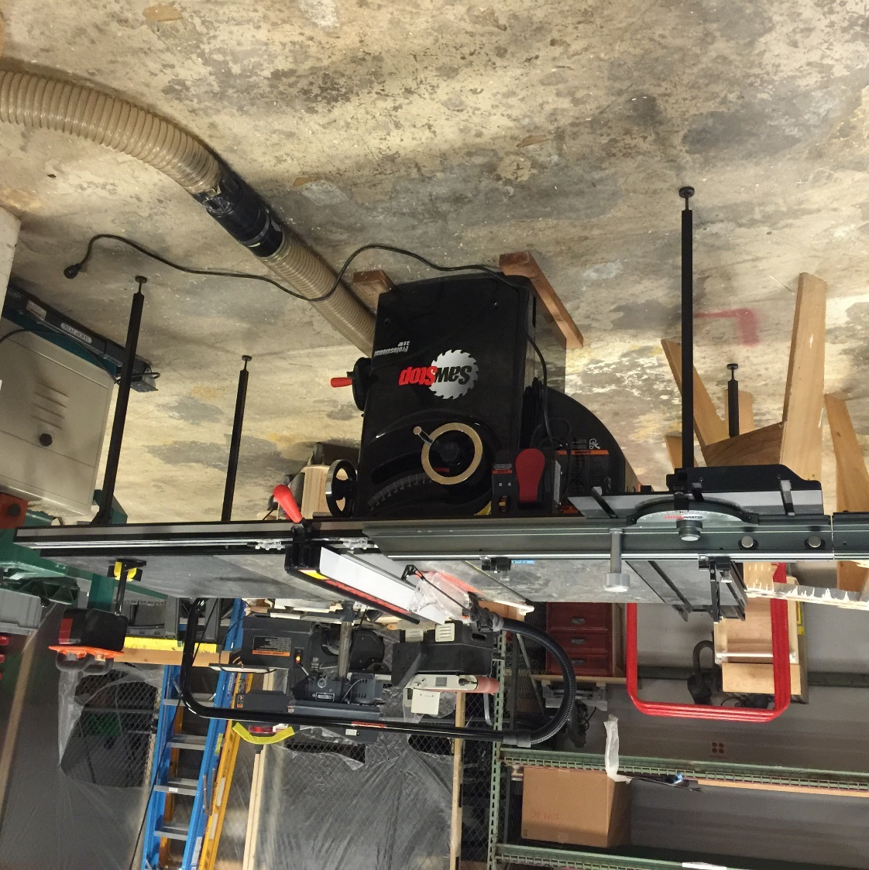

SawStop Professional Cabinet Saw

Recertification Information

Norm Brewer, Philip Gaudette, Ka-Loon Tung

Contents

SawStop 1

Recertification Information 1

Norm Brewer, Philip Gaudette, Ka-Loon Tung 1

SawStop Professional Cabinet Saw 3

Recertification Needed 3

Nomenclature 4

Some Basic Rules 5

Controls and Accessories 6

Powering on the PCS 7

Blink Codes 8

Overload 9

Changing the Blade 10

The Riving Knife and Splitter Guard 11

The Rip Fence 11

The Sliding Table 12

Using the PCS in Bypass Mode 13

The MakerPass 14

The Outfeed Table 14

Appendix 14

SawStop PCS Manual 14

Table 1: SawStop PCS Rules by Material 15

# SawStop Professional Cabinet Saw

Nova Labs has recently upgraded their Delta Unisaw to a [SawStop Professional Cabinet Saw](http://www.sawstop.com/table-saws/by-model/professional-cabinet-saw#overview) with Sliding table. This table saw hereafter referred to as the “PCS” is a major upgrade to the shop, and has important safety features to reduce the severity of injuries that the saw can inflict if you accidentally touch the blade. The PCS senses when electrically conductive materials (such as your hand) touch the blade and it fires an aluminum stop block into the blade. This destroys the blade and cartridge, and will cause several hundred dollars’ worth of damage if it happens. The PCS is not a substitute for safety training, and you can still get hurt using it if you are not careful. Any table saw including the PCS can pick up pieces and throw them violently back at you (kickback), while simultaneously dragging your hand over the blade. You need to **focus your attention completely** on what you are doing while you are using the table saw.

Nova Labs will institute the following policy for the PCS. **If you trigger the blade brake for any reason, you will be required to pay for a replacement cartridge and blade at a cost of $200.** This is not a punishment, it is intended to make you pay attention and learn to operate the Nova Labs equipment properly. There are alternative tools in the woodshop which may be safer than the table saw for cutting wood that you should consider. They include:

1. **The band saw** is safer because it doesn’t kick back. The cutting force is directed down towards the table. For many cuts, the band saw should be the tool of choice. Nova Labs has several band saws with various blade widths for different cutting tasks.
2. The **chop saw** (also called a **miter saw**) is safer and more appropriate for cutting long pieces like 2 x 4 studs. With the chop saw, auxiliary supports, and clamps, it is easy to keep your hands out of harm’s way. The work piece remains stationary, and you don’t have to slide a heavy work piece over the table as you do on the table saw.

1. The handheld circular **saw** and **straight edge** combination is often a good alternative to the table saw for cutting large panels such as a sheet of plywood. One drawback of the circular saw is that it may not produce as clean a cut as the table saw. You can always cut a piece oversized, and once you have cut it to a safer size, then use the table saw to trim the edges and make splinter free cuts. This avoids the problem of handling a large panel on the table saw.

# Recertification Needed

Nova Labs has also decided to ask folks who are currently certified to use the Delta Unisaw table saw to be recertified on the PCS. This recertification is to familiarize you with the new saw and new policies, and to help you avoid accidentally triggering the blade brake. The recertification should take about an hour and you will learn how to change blades, how to avoid triggering the blade brake, and what to do if you do accidentally trigger the brake. Please don’t use the SawStop until you have taken the recertification course. There is a [link](http://www.sawstop.com/images/uploads/manuals/PCS%20Owners%20Manual%20Model%20PCS31230%20V5.0%2009-13.pdf) in the appendix to the full SawStop PCS manual, and you should read pages 40-62 before attending the recertification course. This document is intended to point out the major differences between the PCS and Nova Lab’s previous table saw.

# Nomenclature

The pictures below show some of the parts that come with the PCS. Note in particular the riving knife which is something not available on the previous saw.



# Some Basic Rules

The basic safety rules for safely using a table saw apply to the PCS and are listed below:

* Leave the guards in place whenever you can. Nothing good ever comes from removing them.
* Make sure you can reach the shutoff switch easily if something goes wrong.
* Never use both a miter gauge and the rip fence at the same time. The work piece can bind and cause a kickback. The same rule applies to the sliding fence and rip fence.
* Never attempt freehand cuts. Always use the rip fence, miter gauge, or a sled.
* Only cut wood and soft non-conductive materials such as acrylic or phenolic plastic. **Never cut aluminum or metal of any kind**! Table 1 in the appendix summarizes the materials that can be cut on the PCS.
* Disconnect power from the saw before changing the blade.
* Always use a throat plate
* Keep the blade low, just high enough to clear blade gullet.
* Keep your fingers at least 1 finger length (3”) away from the blade at all times. Use pushers/push sticks to maintain separation and control of the work piece.
* Never cut pieces less than 12” in length without a jig.
* Do not cut boards with loose knots. The knot can come loose and be hurled at you with tremendous force.
* Never reach over the blade while it is spinning.
* Lower the blade below the table when finished using the table saw.
* Support long pieces with auxiliary support (out feed table p. 119) in front of and behind the blade to minimize the force necessary to keep your work safely under control.
* When removing small amounts of wood, several passes that create sawdust are safer than one pass that can kickback small pieces.

In addition, the following rules must be followed with the SawStop.

* Do not rely on the SawStop safety system to protect against unsafe operation. You must be certified to use the table saw, and the proper safety procedures will be taught in this NL course.
* Do not cut electrically conductive materials. This includes metals such as aluminum and copper, materials containing carbon fiber or conductive fillers, and wet or pressure treated wood. Nova Labs has a separate table saw for composite materials, and the metal shop has a bandsaw and milling machine for metals.
* You must only use a single 10” blade, or an 8” dado set with the appropriate 8” dado brake cartridge. Never use a moulding head as the brake is not designed to stop a moulding head.
* Never use a non-conductive blade such as an abrasive blade.
* Even when the power has been switched off, the safety brake is active until the blade stops completely.
* Keep all metal items off the top of the saw. If one accidentally contacts the blade – goodbye $200.

# Controls and Accessories

Page 40 of the PCS manual shows the controls for the saw. Turning the elevation knob clockwise raises the blade. Be gentle with the lock knobs, as only slight pressure is needed to lock an adjustment.

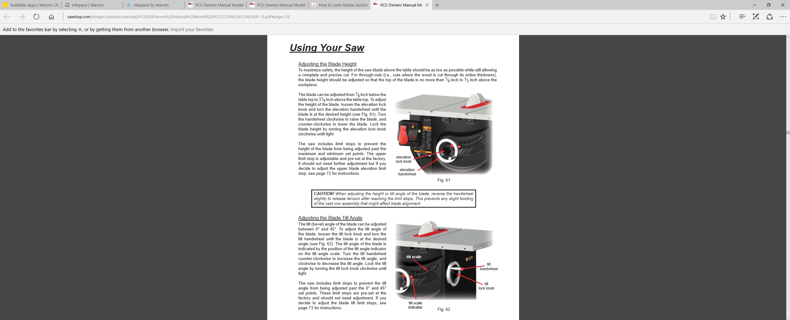

# Powering on the PCS

Make sure the PCS is plugged in. Use your badge to activate the MakerPass to apply power to the PCS. Page 41 of the PCS manual shows the control box. Then follow the instructions below:

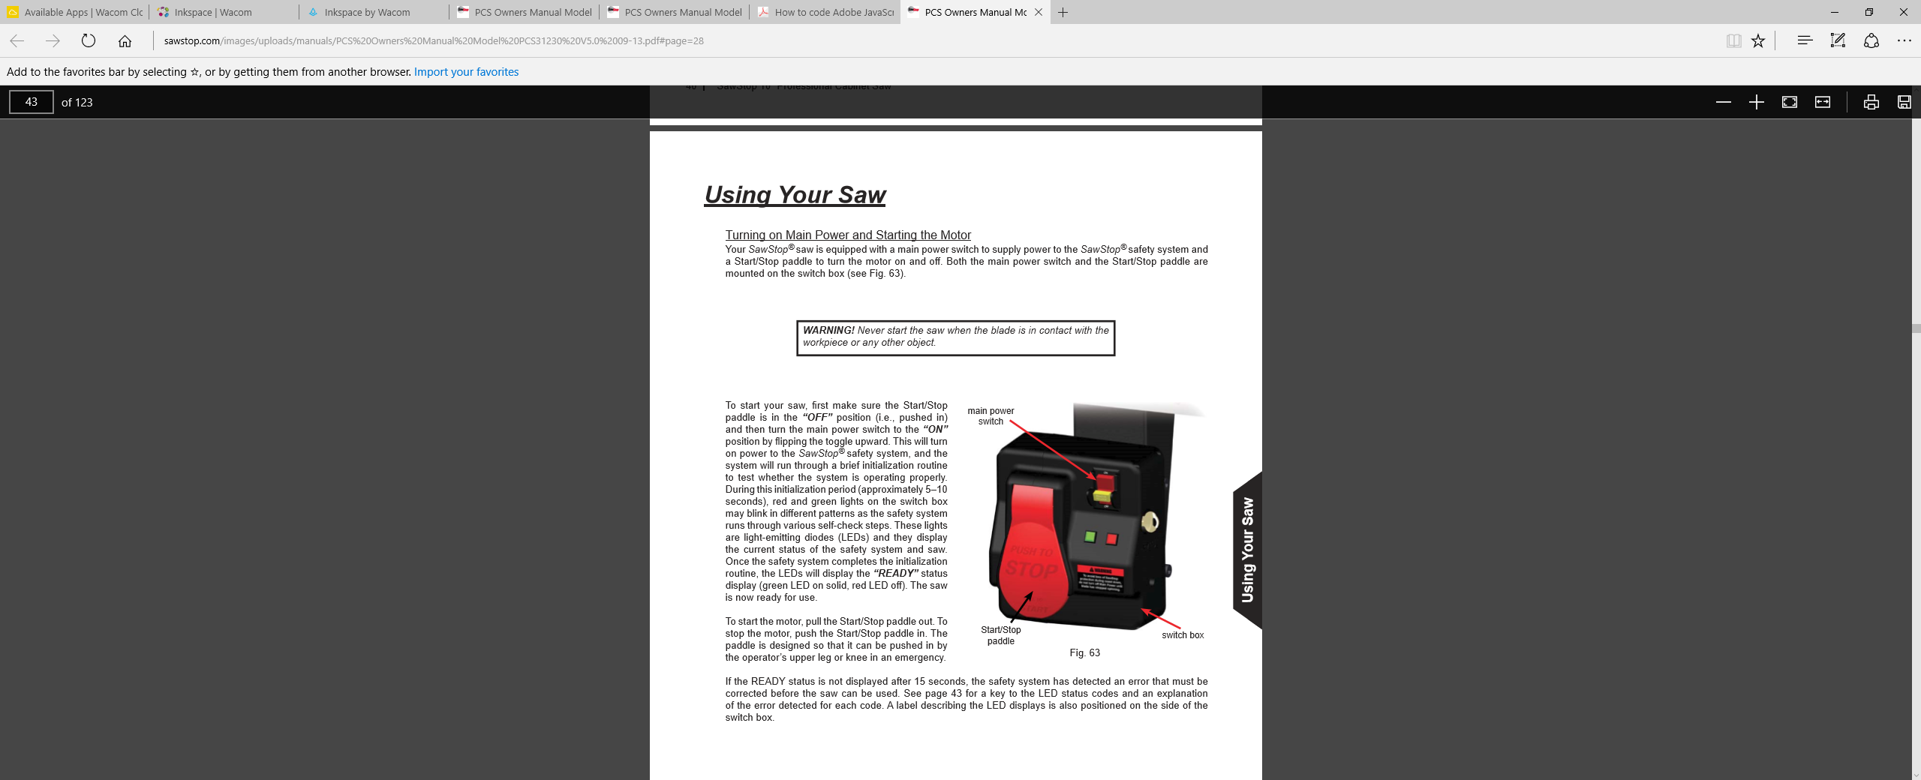

# Blink Codes

The LED Lights on the front of the control panel show the current status of the safety System. See Page 43 of the PCS manual for the blink codes (Reproduced below). You will have to refer to these in the event the PCS does not start normally.

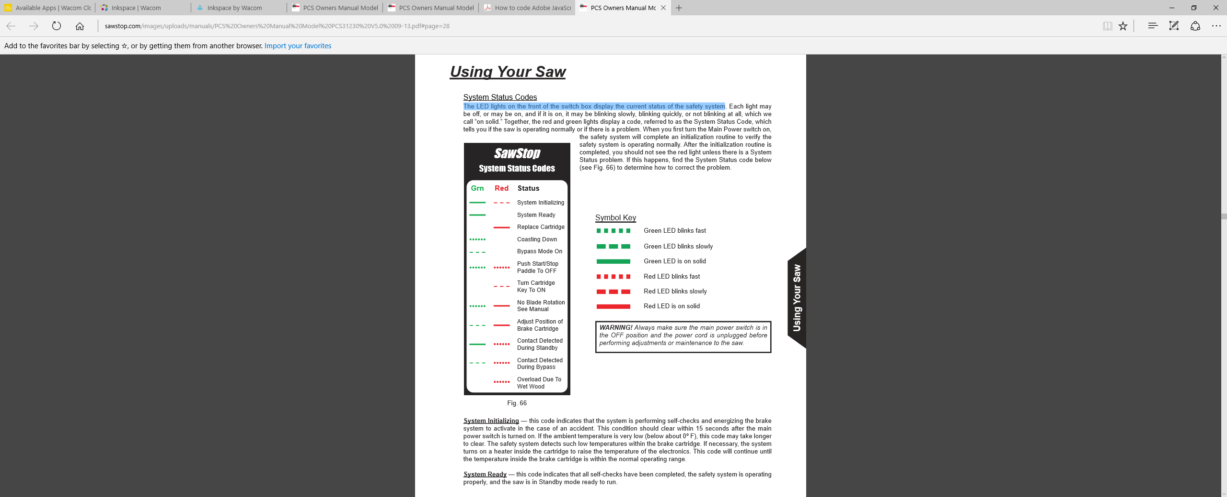

# Overload

The PCS has a thermal overload switch that can cut power to the motor if the saw is overloaded. This typically happens when ripping thick hardwood, especially with a full kerf combination blade. Page 42 of the PCS manual describes this feature.

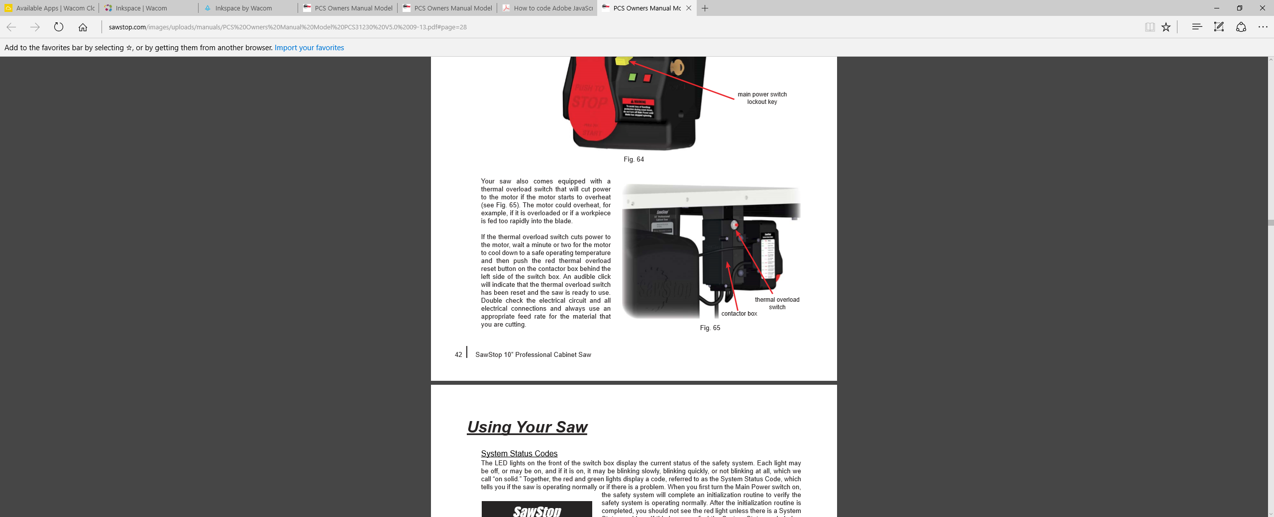

# Changing the Blade

Nova Labs has 3 blade choices available, and you can bring your own blade (byob) to use if you desire. If you byob, it must be either a 10” single blade, or an 8” dado set, and no other sizes will work. Nova Labs has a 10” thin kerf combination blade that can be used for both crosscutting and ripping, and a thin kerf rip blade that you might want to use if you have a lot of ripping to do.

Blade changing steps:

1. Turn off the PCS Main power switch
2. Unplug or shut off the power to the saw via the master shutoff
3. Remove throat plate, overarm guard, and riving knife.
4. If changing blade size ie. 10” to 8” dado, rotate cartridge key clockwise, remove cartridge, and replace with the appropriate size one.
5. Locate the wrenches, loosen and remove the arbor nut and stabilizing washer, and remove the blade.
6. Insert the new blade, and stabilizing washer if there is room on the arbor. Replace nut and tighten firmly, but don’t overdo it.
7. Adjust cartridge height using yellow gauge and hex wrench
8. Put back guards as applicable, throat plate, and restore power.

Page 59 in the PCS manual has more information on this procedure.

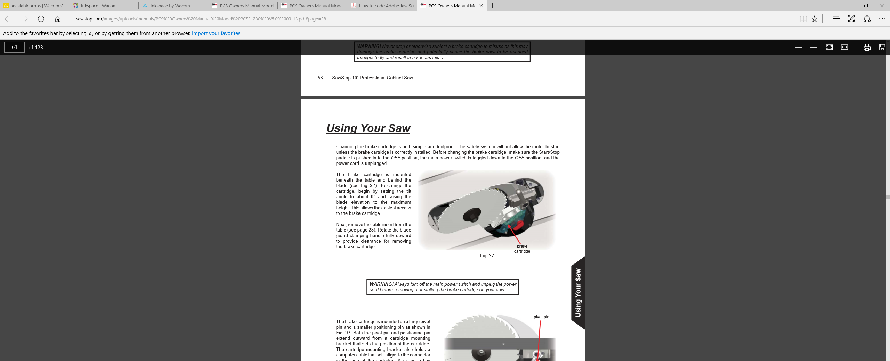

# The Riving Knife and Splitter Guard

The splitter guard is an important safety device that keeps your hands away from the blade, aids in dust collection, and has anti-kickback pawls to reduce ejection of materials. Of course, if you are following the 3” rule you hands will never be near the blade anyway. You should use this guard whenever possible. You have to remove it when you are not making a through cut because the guard rides in the kerf made by the blade.

The purpose of the riving knife is to ride slightly above and behind the blade to keep the workpiece from rotating away from the rip fence. It can only be used with 10” blades, never with dado cutters, and must never contact the blade or it will trigger the blade brake. You can leave the riving knife in place even when you not making a through cut as it rides in the kerf and the top of the knife is slightly below the blade.

DO NOT RAISE THE BLADE THROUGH A SOLID PIECE WITH THE RIVING KNIFE IN PLACE AS THIS WILL NOT WORK and is likely to trigger the blade brake. This is a procedure commonly used to cut a clearance slot in a zero clearance insert.

The wood stop is intended to keep you from starting a cut and finding out half way through that the blade is set too low and does not cut all the way through the workpiece.



# The Rip Fence

The rip fence is identical in operation to the previous saw. However, we have not yet fabricated a sacrificial fence to use when the blade is close to the blade, so you may need to make your own if you need to perform this operation. DO NOT CUT INTO THE RIP FENCE! Also note that the width scale for the rip fence assumes you have no sacrificial fence in place, and that you are using the standard thin kerf combination blade. If you change the blade, you will have to recalibrate the scale. This is always a good practice in a shared facility.

# The Sliding Table

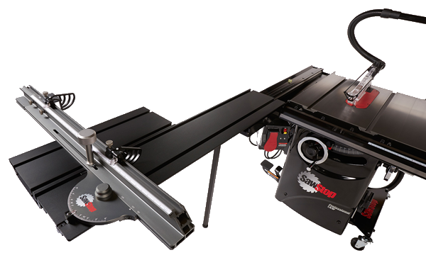

The sliding table is like a giant miter gauge and replaces some of the functionality of a sliding sled. There is also a conventional miter gauge available with the PCS. The sliding table is especially useful for cutting the end square on wide pieces. However, you will have to square the miter gauge with the rip fence using a framing square before you use it if you want accurate cuts. Don’t assume either the length scale or angle is accurate for the sliding table, it will change with whatever blade is being used, and whoever last used the saw

**Do not use the sliding table and the rip fence** at the same time. If you need to make repetitive cuts, clamp a block to the rip fence and use it as a length gauge.

You can quickly remove the sliding table fence if it is in the way by loosening two socket head hex bolts and the locking knob. The bolts are indicated in the drawing below, and have a reverse thread, so you turn the bolt clockwise to loosen it.

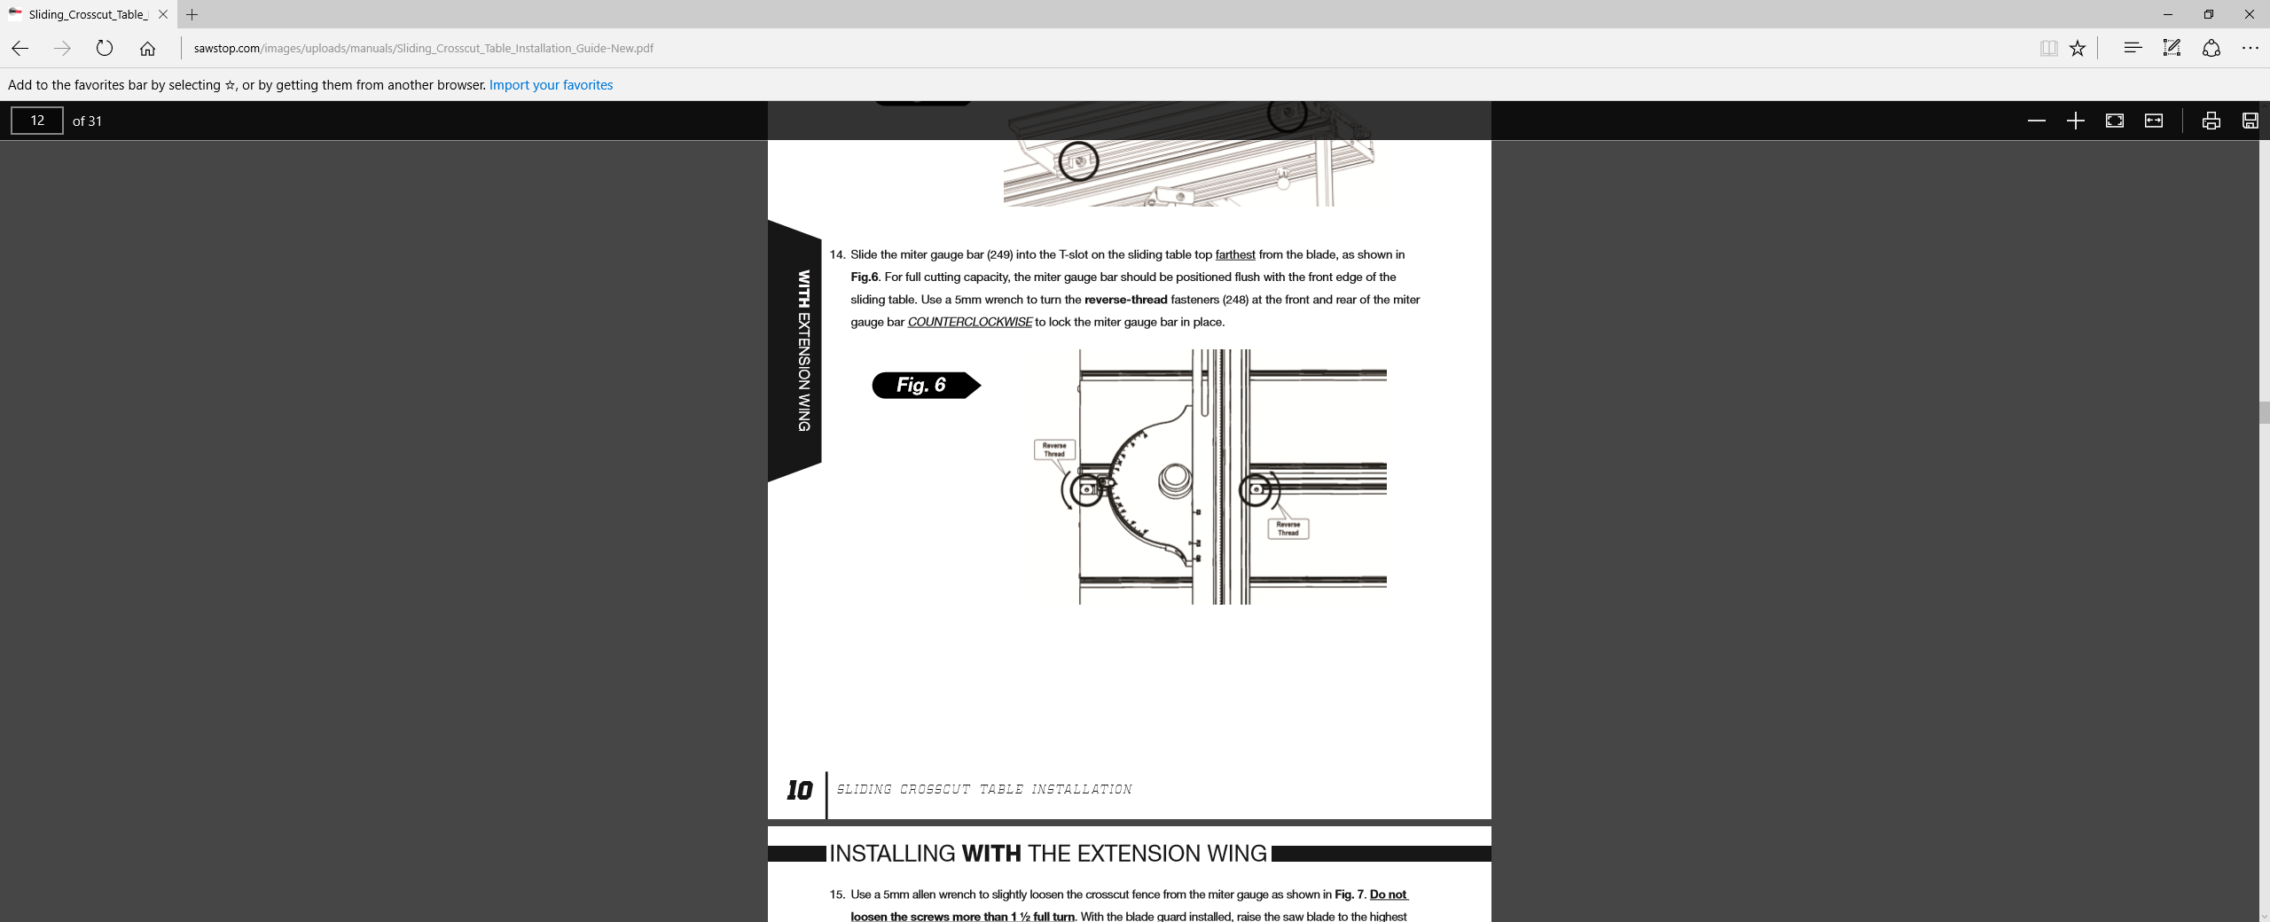

# Using the PCS in Bypass Mode

Page 56 of the PCS manual describes how to use Bypass mode to cut electrically conductive materials or wet wood. **Do not use this mode to cut aluminum**, even though the instructions below refer to that. See table 1 in the appendix for a list of materials you can cut on the Nova Labs PCS.

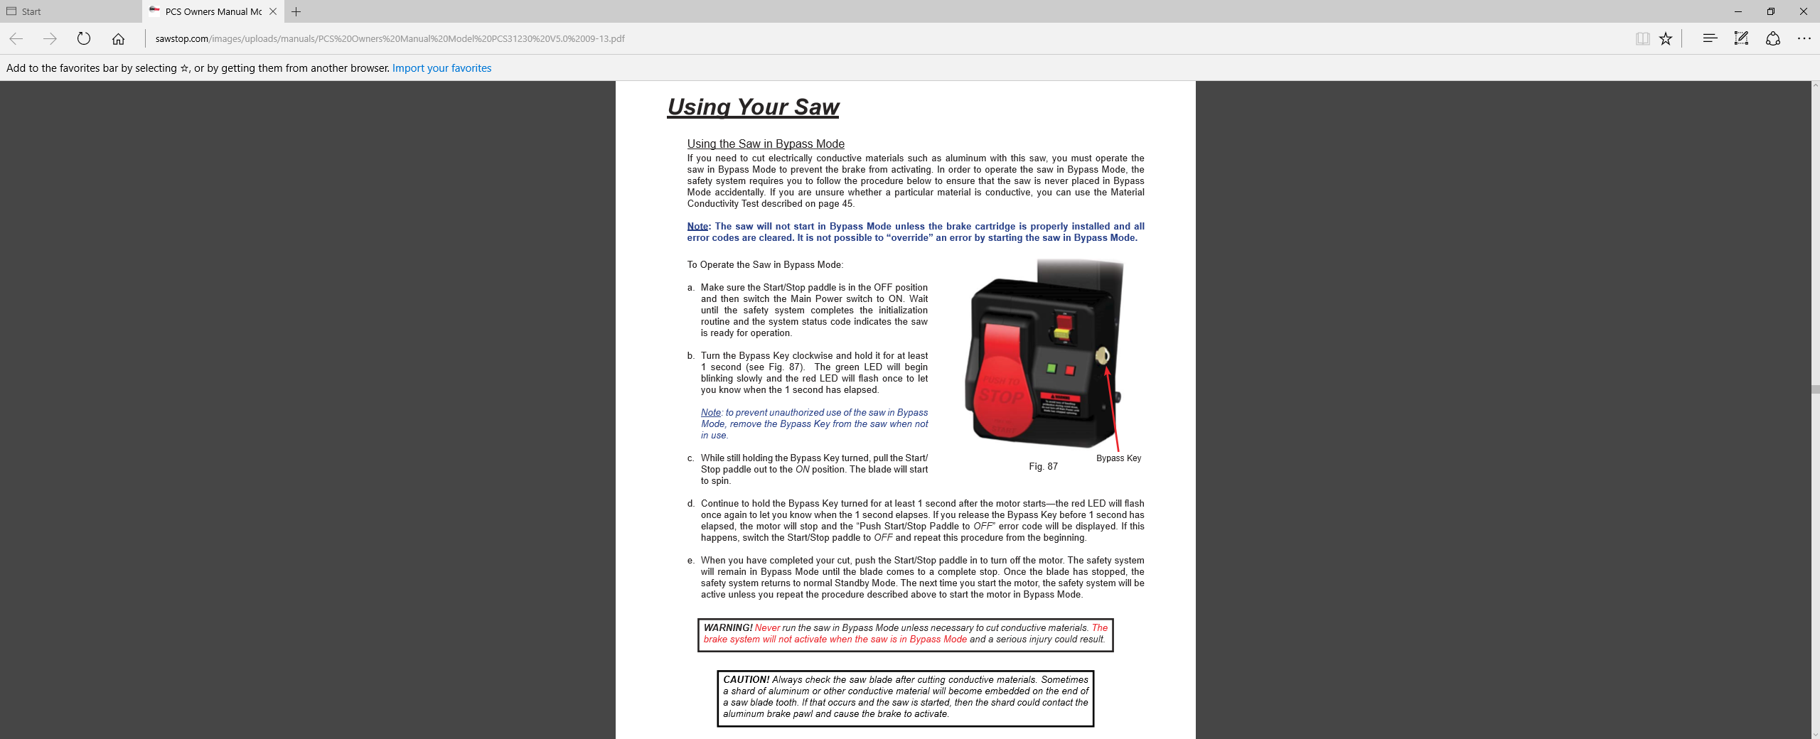

# The MakerPass

Nova Labs is in the process of implementing a MakerPass system for all stationary power tools in the woodshop, plus a few other tools such as the laser cutter. This system will let you turn on power to a tool with your badge if you have been certified to use that tool and your name has been entered in a database. The MakerPass communicates wirelessly with a database server to check your credentials, and if you are approved, it will apply power to the tool for a limited amount of time, and record your access. The PCS MakerPass badge reader is located to the right of the PCS on a post and is labeled to indicate what it does.

# The Outfeed Table

The outfeed table is an important safety feature on the PCS as it keeps you from having to reach over the blade when you push a piece through the saw. Don’t use the PCS if there is no outfeed table attached because it is dangerous to reach over the blade. Keep the outfeed table clear of debris and material. It is not an assembly table. Use a workbench for that.

# Appendix

## SawStop PCS Manual

<http://www.sawstop.com/images/uploads/manuals/PCS%20Owners%20Manual%20Model%20PCS31230%20V5.0%2009-13.pdf>

## Table 1: SawStop PCS Rules by Material

|  |  |  |  |
| --- | --- | --- | --- |
| Material | Cut with PCS | Blade | Recommendations |
| Dry Wood with no included metal | Yes | General purpose blade for most cuts | The stock must have a flat face and reference edge for safe operation. Use the rip blade for faster rip cuts in thick stock. |
| Plywood, MDF, OSB other wood sheet goods including those with laminated surfaces (except metal laminate) | Yes | General purpose blade | For best results, experts can consider buying and using their own specialty blade. |
| Wet Wood, pressure treated wood, recycled wood that may contain metal or nails | Caution, wet wood can trigger the safety stop. |  | The PCS Manual explains methods for cutting wet wood on page 56. |
| Aluminum or other metals | No |  | Metal shop has better alternatives, or use a hack saw. Impossible to get swarf out of saw which may trigger the brake for next user. |
| Dado cuts in lumber or sheet goods | Yes | 8” dado cutter only, no 6” dados | blade and cartridge changes as described in the PCS manual. |
| Rough Lumber | No |  | The stock must have a flat face and reference edge for safe operation. Use the band saw, jointer, and planer first to prepare surfaces. |
| Foam | No |  | It makes a mess of the blade and the saw interior. There is a blade for foam available for 7.25" circular saws. |
| Composites | No |  | Composites can degrade blades and trigger the safety stop. The metal shop has better alternatives available. |
| Plastics | No |  | Plastic. No. It makes a mess. Experts can use their own specialty blade if they know how to cut plastic and clean up thoroughly. Even then a saw with slower blade speed will produce better results. |